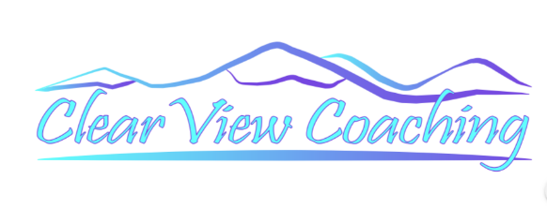
What is Coaching?
Simply put, coaching is the art and science of helping others make change. The coaches’ goal is to help those he or she serves in making Transformational and Sustained life changes.
There are many different categories of coaches; Business Coach, Health/Wellness Coach, Financial Coach, Relationship Coach. These all focus on a particular area of a person’s life.

So what is a Life Coach?
Life Coaching is a broader field that focuses on all elements of a person’s life.
A Life Coach helps people tap into their full potential, and define and achieve their goals for Who they want to Be, What they want to Do, and How they want to Live.

How does it work?
As a Life Strategy Coach, I partner with my clients to help them do the following:
- Slow Down and Reflect
- Gain Clarity in how their Life is currently moving
- Begin Dreaming again
- Identify gaps in their current life and their dream life
- Assist in creating a Strategic Plan to get them closer to becoming the Best Version of themselves and to living their Best Life!

Why I might need a coach?
I believe everyone can benefit from the help of a coach. Let’s face it, we all have times when we get ‘stuck’ and know we want and need to change, but have not been able on our own to move in any direction. Working with a coach; someone who is simply there to listen, ask questions, encourage, share ideas and help us stay accountable to ourselves, is just what we need to get unstuck. Working with a coach helps us see new perspectives, build confidence and realize new possibilities. A coach helps us experience a shift in ways that Transformational Change happens!
Would you agree, in our overstimulated, highly competitive world we can easily lose sight of the people and things most important to us? But we have a Choice! It IS possible to Live a better more meaningful Life! “You can’t go back and change the beginning, but you can start where you are and change the ending.” –C.S. Lewis

